**Installation of Hardline Hangar**

# Assembly:

1. Roll out each individual module next to each other. (A clear and clean surface is preferable)

2. Fold the modules as shown in this sketch; the length of the fold must be adapted to the size of the module (so that the assembly straps on the underside reach forward).

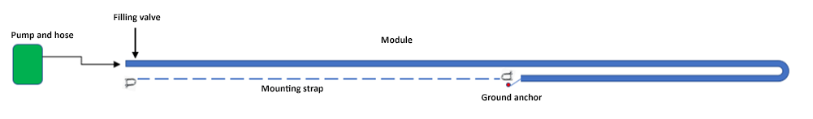

3. "Fold" up the long side of the module and connect the mounting straps, one side at a time.

4. Connect both mounting straps on the underside of each individual module with the two supplied shackles. The straps must lie on the underside of the module, on the side that lies down towards the ground/substrate, opposite the large fill valve.

5. Check that the filling valve on the module is in the "locked/closed" position by turning the inner part slightly.

6. Connect the hose to the filling valve on the module, then to the pump. (See instructions at the bottom of the page)

7. Place the pump some distance from the ground so that it does not suck dirt and sand into the fan.

8. Start the pump (it takes a few seconds before the pump starts). The elements will then fill with air and rise up. If the tent is over 12 meters wide or more, you may need to "help" the module up with a small push.

9. When using several modules, repeat the procedure and place the modules next to each other, securing them together with the waterproof zippers when they are fully inflated. Use the supplied rope to make pulling the zippers together easier. Feel free to use a ladder if the height is significant.

10. Once the modules have been assembled together, attach the supplied internal roof gutter with Velcro to prevent water from penetrating and running out the sides.

11. Attach the modules to the ground at the correct distance, equal to the width of the ordered hall. This is done by using soil spikes through the D-rings at the bottom of each module — two on the outside and one on the inside. Use all supplied soil spikes. Do not attempt to pull the hall together with the zippers on the end walls. Use a demolition hammer with special tools to knock down the earth spikes. Alternatively, the module can be attached to the ground using the ballast skirts (see sections 12 and 13).

12. Fasten the wind protection using the safety straps (the upper D-rings on the outside) from the module to the supplied straps and ground spikes.

13. Then mount the ballast skirt at the bottom of the module's long wall. This adds extra security for the hall. Use ballast or some form of weights/sand.

14. Fill the ballast skirt with sand or other ballast to protect against wind from the underside.

15. Before installing the end walls, check that the hall has the correct width, so that the load on the zippers used to install the end walls is not excessive.

16. If the hall was ordered with a floor, it is installed with zippers on the inside of the modules.

17. Once the hall has been assembled, connect the control/manifold system. This is done by screwing the manifolds into the valve on the inside of the hall. Adapt and cut the main hoses to the correct length, and screw them to the manifold using the supplied hose clamps. Connect the end hose to the pump and start. The pump will now top up and control the air pressure in the entire hall based on, among other things, the outdoor temperature.

# Dismantling/Moving: Inflate/Deflate Hall:

- Open the valve — start with the small one, then the large one, and the air will be released.

- For more efficient emptying of the last part of the air volume, connect the pump (move the hose to the suction side of the pump) and press start.

- Roll the module (as tightly as possible) towards the open filling valve to force out as much air as possible. Place the module on a pallet with a base.

_Remember: This is a product that is self-supporting when filled with air and must not be dragged against sharp objects, as this may cause leakage._

# Pump for Hangar (Example photo)

(Hangar)

# Instructions for using the Pump:

1. Connect the filling hose to the valve on the module and further to the exhaust connection on the pump.

2. The pump has a pre-set pressure calculated for the hall you have purchased.

3. Connect the power supply to the pump.

4. Start the pump by turning on the main switch on the outside of the pump cabinet. The pump stops automatically when the correct pressure is reached (from 350 to 500 millibars).

5. Emptying the module using the pump:

- Move the hose to the suction connection/plug at the bottom of the pump cabinet.

- Open the door and fold over the plate at the bottom right to increase suction.

_NB: When installing larger hangars, special air-blowers are used. The modules must be connected together before air-filling starts._